Spring data jpa

Spring data jpa is a package or dependencies which is used to create the tables in Mysql workbench using Java with springboot.

Steps to create spring data jpa
- Open Spring Initializer Create the maven project by adding the dependencies like spring data jpa and generate the zip file
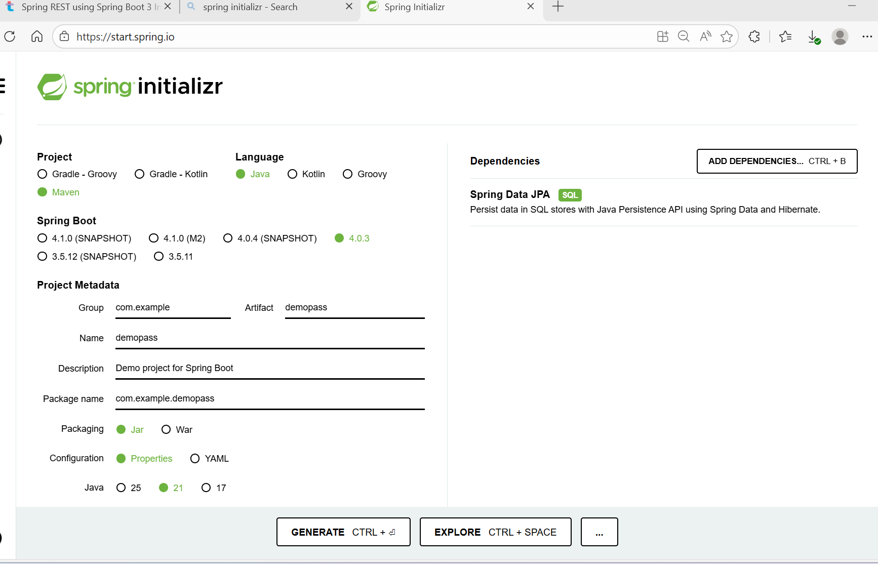

- Import the project in eclipse
- Add the external jar as MySQL using build path to that maven project
- Create the service classes, Repository interfaces and main class.

- Main class (With the query)
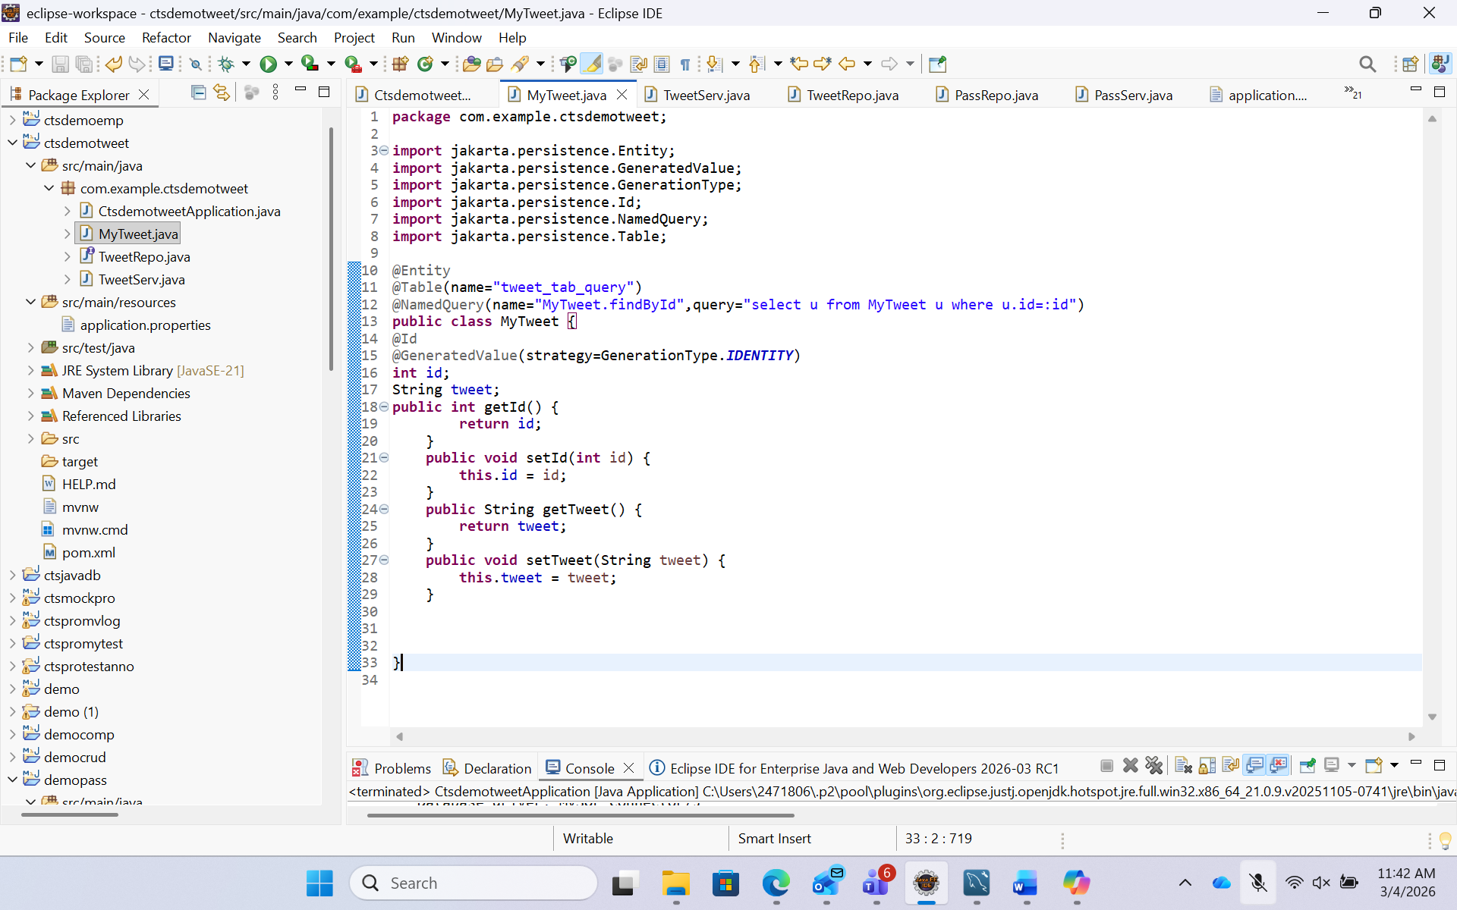

- Service class
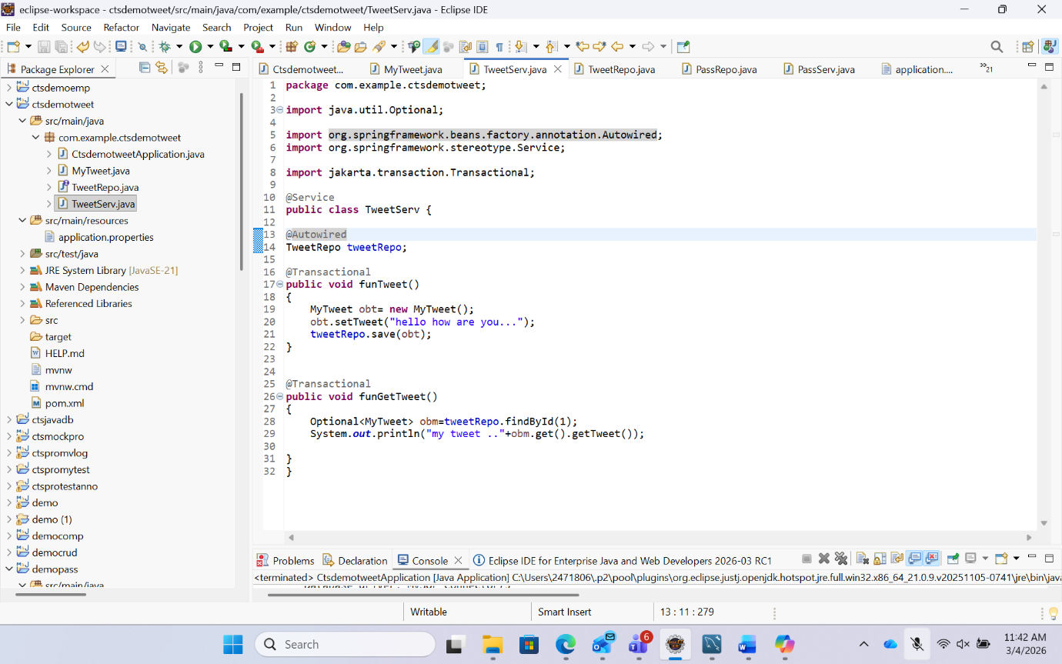

- Repository Interface
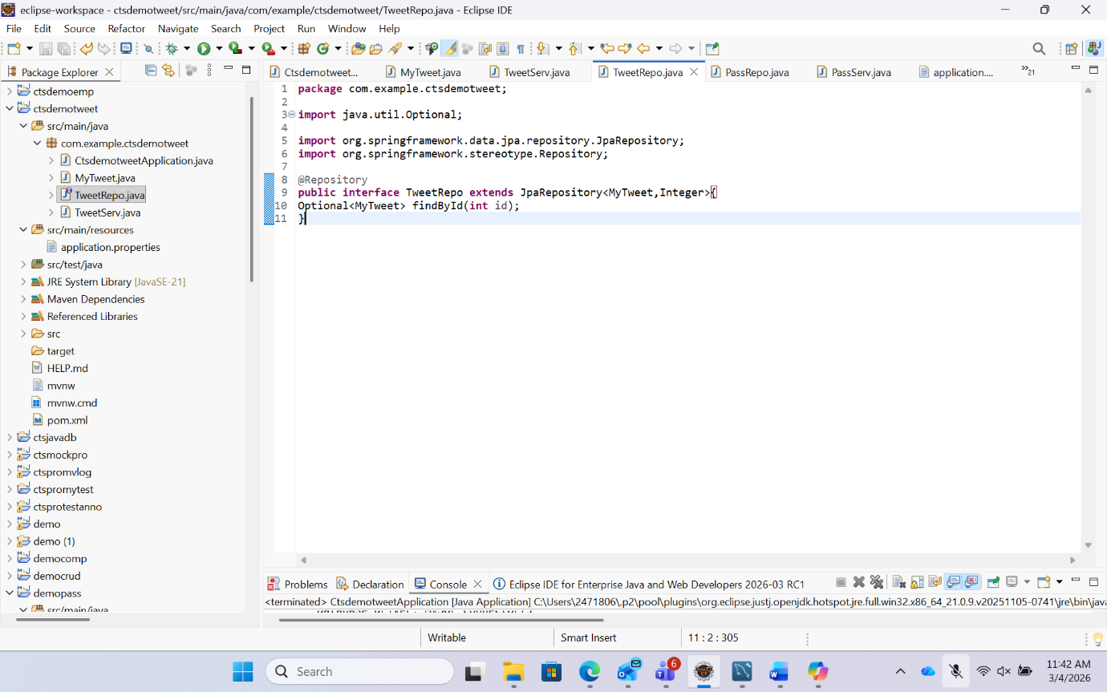

- Update the springboot application
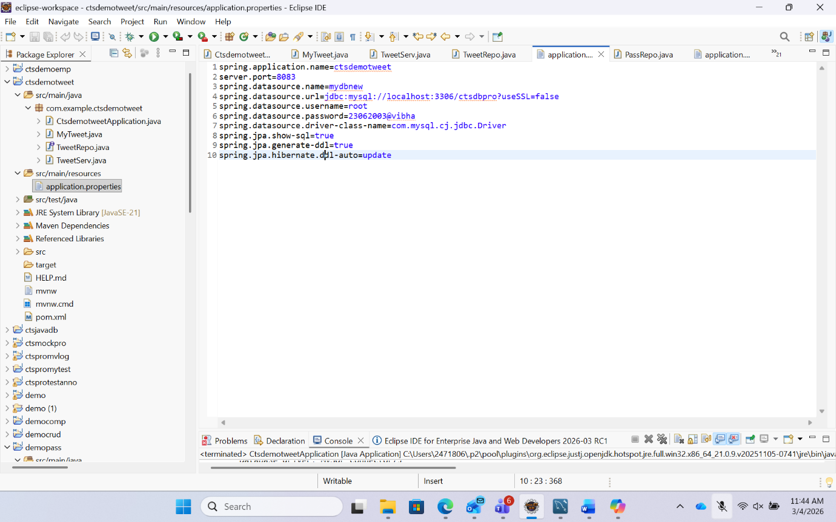
- Update the properties file

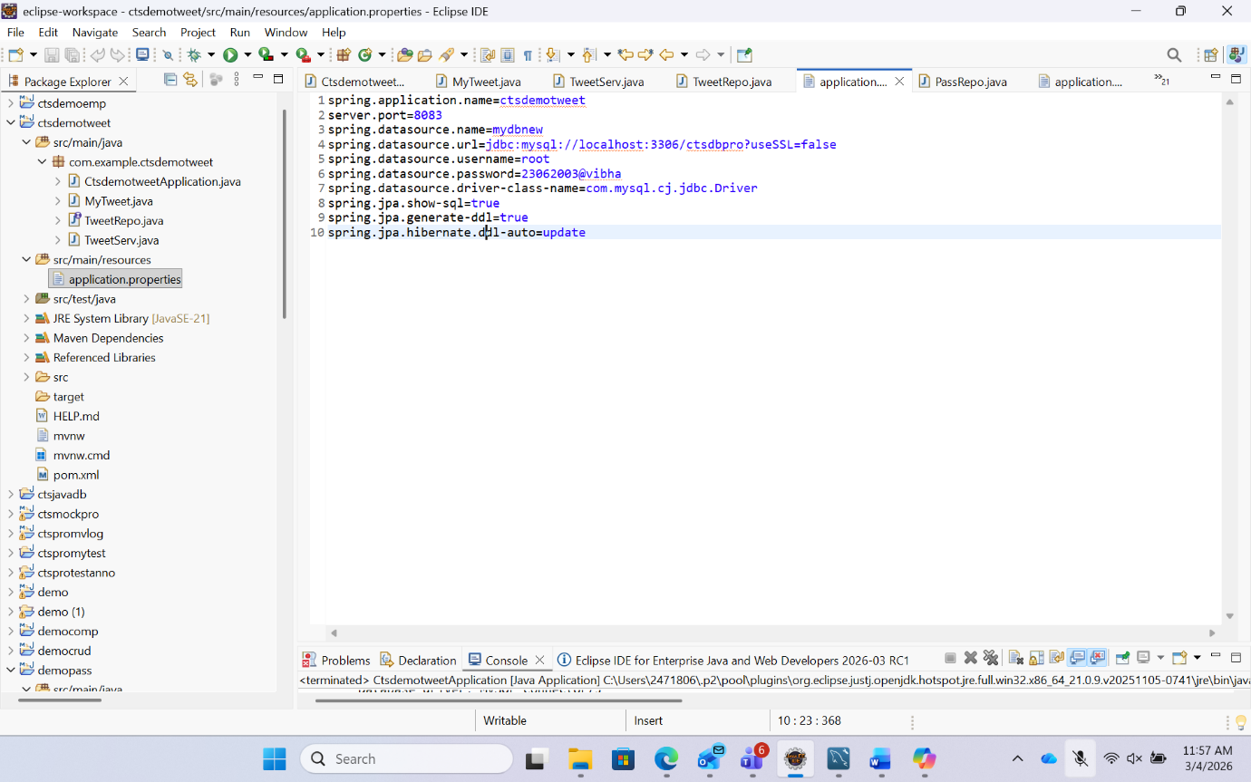

- Run the springboot application then you can see the mysql workbench the table is created in the provided database along with the value.

